PROJECT DESIGN PHASE
Title: Visitor Management System
1. Overview
The Project Design Phase focuses on defining the architecture, workflow, data structure, and functional components of the Visitor Management System. The system is designed using ServiceNow Zurich Platform components such as Custom Tables, Forms, Client Scripts, Flow Designer, Notifications, and UI Actions. The design ensures efficient visitor registration, automated notifications, and visitor check-in management.

2. System Architecture Design
The Visitor Management System follows a simple architecture where users enter visitor details through a ServiceNow form. The data is stored in a custom Visitor table. Business logic is implemented using Client Scripts and Flow Designer. Security personnel receive email notifications, and visitor status can be updated through a UI Action.
Architecture Components
- User Interface (Visitor Registration Form)
- Visitor Custom Table
- Client Script Validation
- Flow Designer Automation
- Email Notification Service
- UI Action for Check-In
- Security Team

3. Database Design
Custom Table: Visitor
Field Name | Data Type | Description
Visitor Name | String | Name of Visitor
Phone Number | String | Contact Number
Email | Email | Visitor Email
Company | String | Visitor Company
Person To Visit | Reference | Employee Being Visited
Visit Date | Date/Time | Date of Visit
Purpose | String | Reason for Visit
Status | Choice | Registered / Checked In

4. Flow Diagram
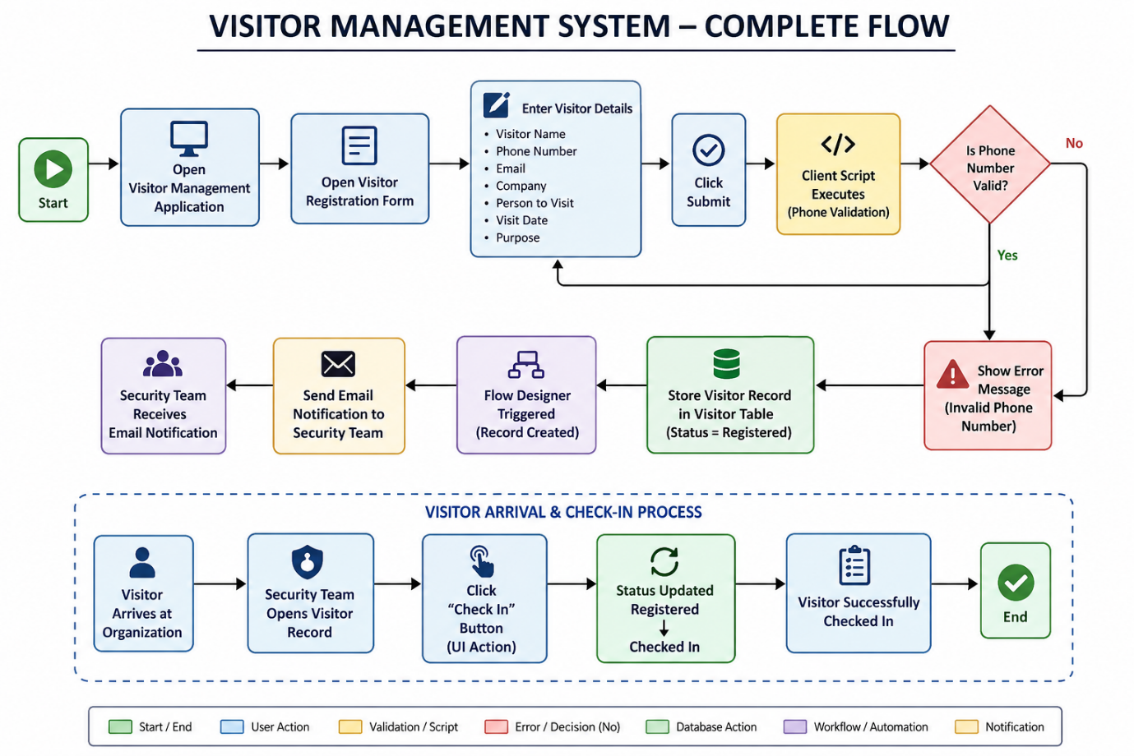

5. Module Design
Module 1: Visitor Registration
Purpose:
To collect visitor information and store it in the system.
Functions:
- Register Visitor
- Save Visitor Details
- Maintain Visitor Records

Module 2: Phone Validation
Purpose:
To ensure valid phone numbers are entered.
Functions:
- Validate Phone Number
- Prevent Invalid Submission
Technology Used:
- Client Script

Module 3: Email Notification
Purpose:
To notify the Security Team when a visitor is registered.
Functions:
- Trigger on Record Creation
- Send Notification Email
Technology Used:
- Flow Designer

Module 4: Visitor Check-In
Purpose:
To update visitor arrival status.
Functions:
- Check In Visitor
- Update Status Field
Technology Used:
- UI Action

6. User Interface Design
The Visitor Registration Form contains the following fields:
- Visitor Name
- Phone Number
- Email
- Company
- Person To Visit
- Visit Date
- Purpose
- Status
The form is designed to be simple, user-friendly, and easy to access.

7. Design Summary
The Visitor Management System design provides a structured and automated approach for visitor registration and monitoring. The system integrates ServiceNow forms, custom tables, client-side validation, workflow automation, and status tracking to ensure efficient visitor management and improved organizational security.

